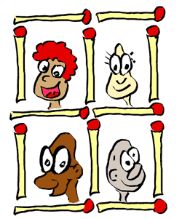
Grade 7:Investigating Matchstick Patterns :
In this task you are going to be assessed against criterion B; Investigating patterns and criterion C; communication in maths
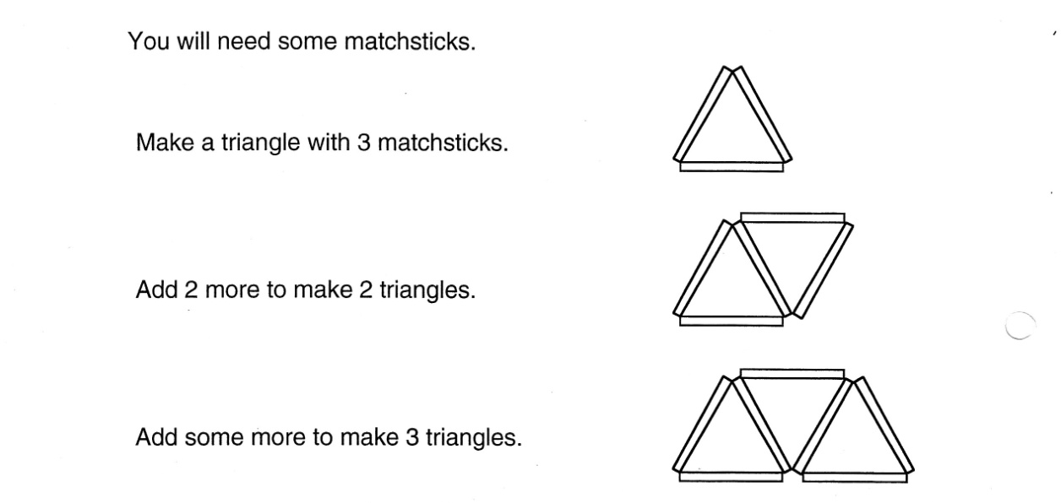
Pattern number 1

Add some more matchsticks to make 4 and 5 triangles. Draw the diagrams.

Complete this table:
Number of triangles | 1 | 2 | 3 | 4 | 5
Number of matchsticks | 3

What pattern do you see?

Use your pattern to find how many matchsticks you would need for:
- 6 triangles

- 10 triangles

- 20 triangles

How would you find the number of matchsticks for 50 triangles?

Pattern number 2
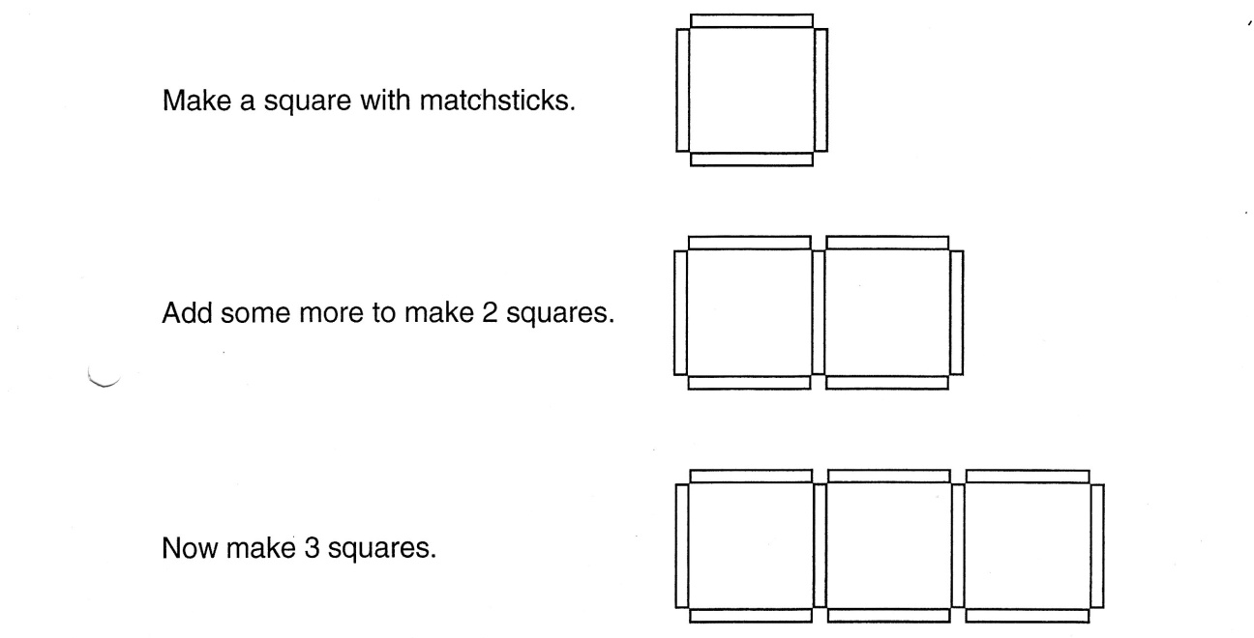

Add some more matchsticks to make 4 and 5 squares. Draw the diagrams.

Copy and complete this table:
Number of squares | 1 | 2 | 3 | 4 | 5
Number of matchsticks | 4

State the patterns you see.

Use your pattern to find how many matchsticks you would need for:
- 6 squares

- 10 squares

Develop a rule or relationship that would allow you to find the number of matchsticks needed for 50 squares.

Why does your rule or relationship work?

Use your rule or relationship to find the number of matchsticks you would need for 88 squares.

Pattern number 3
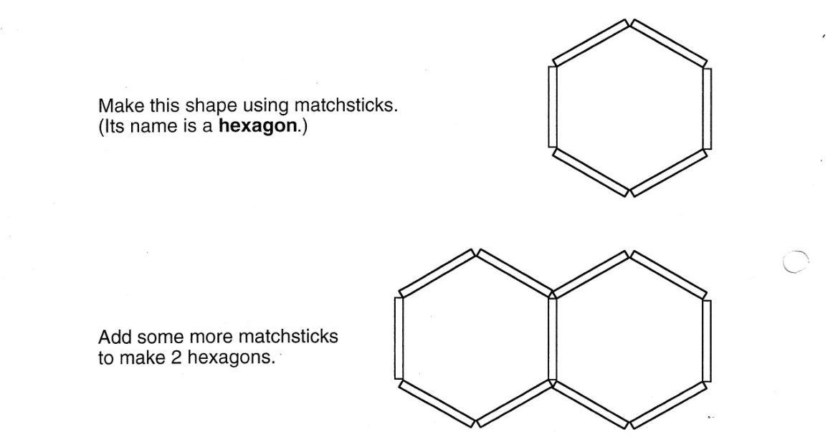

Add some more matchsticks to make 3 and 4 hexagons. Draw the diagrams.

Copy and complete this table:
Number of hexagons | 1 | 2 | 3 | 4 | 5
Number of matchsticks | 6

State any patterns you see.

Use your pattern to find how many matchsticks you would need for:
- 6 hexagons

- 10 hexagons

State rule or relationship that would allow you to find the number of matchsticks needed for 50 hexagons.

Explain why you rule works.

Find the number of matchsticks you would need for 67 hexagons.

Pattern number 4
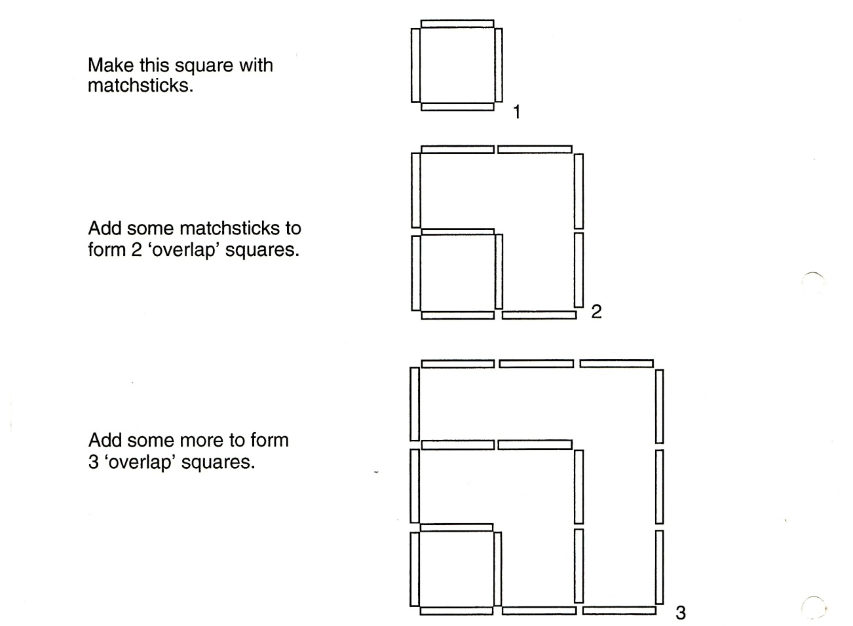
A more difficult pattern

Add some more matchsticks to make 4 and 5 overlaps. Draw the diagrams.

Copy and complete this table:
Square number | 1 | 2 | 3 | 4 | 5
Number of matchsticks | 4 | 10

State any patterns you see.

Use your pattern to find how many matchsticks you would need for:
- Square number 7

- Square number 10

Write a rule to find how many matchsticks would you need for square number n?

Use your rule to fine the number of matchsticks needed for square number 25.

Explain why you rule or relationship works.

